ECE 637 Lab 7 Report

Image Restoration

Xihui Wang

**Section1 – Minimum Mean Square Error (MMSE) Linear Filters**

**1.1 The four original images**



Fig 1-1-1 The original *img14g.tif*



Fig 1-1-2 The blurred version *img14bl.tif*



Fig 1-1-3 The noisy version *img14gn.tif*



Fig 1-1-4 The noisy version *img14sp.tif*

**1.2 The output of the optimal filtering for the blurred image and the two noisy images**

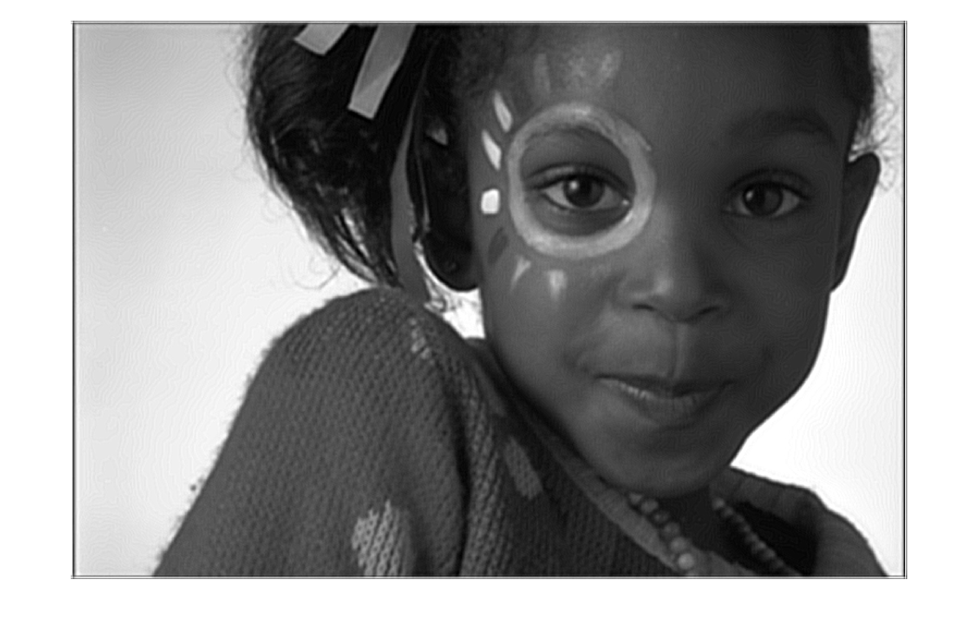

Fig 1-2-1 The output of the optimal filtering for blurred image *img14bl.tif*

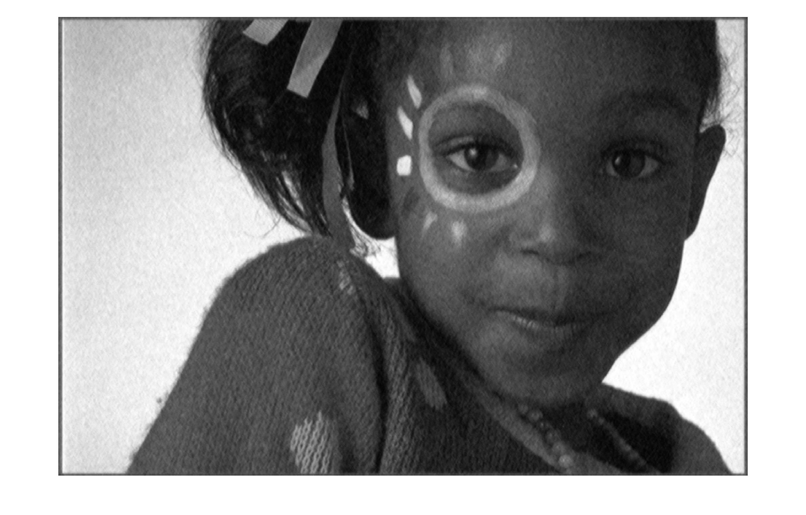

Fig 1-2-2 The output of the optimal filtering for noisy image *img14gn.tif*

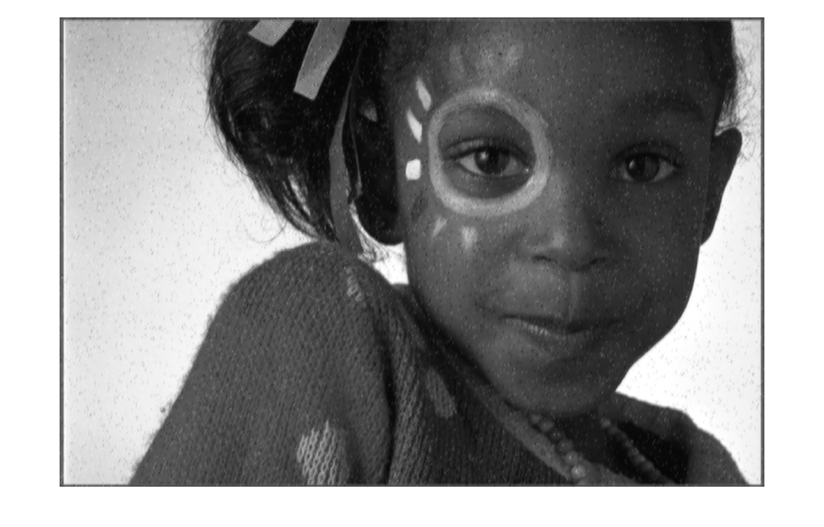

Fig 1-2-3 The output of the optimal filtering for noisy image *img14sp.tif*

**1.3 The MMSE filters that I computed from the blurred image and two noisy images**

Table – 1 Filter coefficient $θ^{*}$ calculated from *img14bl.tif*

$$θ^{*}=$$

0.3720 0.2052 -0.9682 1.0572 0.1961 -1.0020 0.9254

-0.0431 0.4069 -1.2219 -0.0281 -0.6146 -1.3229 0.4024

-0.3541 -0.3242 -0.4810 0.3321 0.7580 -0.0871 -0.7923

1.1089 -2.4308 1.9317 3.7782 1.5691 -0.0701 0.0615

0.3791 -0.4590 -1.1045 1.2263 0.8358 -1.4710 0.3905

-1.0990 -0.1802 -0.2944 1.0624 -1.8928 -1.9628 0.8126

1.1560 0.4776 -1.7439 0.6483 0.2948 0.2604 0.3042

Table – 2 Filter coefficient $θ^{*}$ calculated from *img14gn.tif*

$$θ^{*}=$$

0.0165 0.0259 0.0044 0.0050 -0.0080 0.0302 -0.0259

-0.0055 0.0053 0.0355 0.0205 0.0464 0.0091 0.0066

-0.0105 -0.0125 0.0674 0.0731 0.0470 0.0290 -0.0030

-0.0091 -0.0153 0.0476 0.2306 0.0891 -0.0175 0.0011

-0.0050 -0.0222 0.0423 0.1117 0.0650 -0.0118 0.0069

-0.0044 0.0079 0.0307 0.0268 0.0088 -0.0063 0.0192

-0.0053 -0.0043 0.0154 0.0127 0.0140 0.0183 0.0054

Table – 3 Filter coefficient $θ^{*}$ calculated from *img14sp.tif*

$$θ^{*}=$$

0.0080 0.0048 -0.0016 -0.0050 0.0257 -0.0209 -0.0185

0.0017 -0.0016 0.0558 0.0267 0.0435 0.0214 0.0196

-0.0010 0.0042 0.0413 0.0968 0.0212 -0.0196 0.0199

-0.0014 -0.0203 0.0350 0.2652 0.1492 -0.0287 0.0083

0.0252 0.0023 0.0612 0.0965 0.0154 -0.0412 0.0233

-0.0099 -0.0006 0.0313 0.0497 0.0143 0.0038 0.0131

-0.0407 0.0162 -0.0068 0.0100 0.0079 0.0129 -0.0110

**Section2 – Weighted Median Filtering**

**2.1 The results of median filtering**



Fig 2-1-1 The output of the optimal filtering for blurred image *img14bl.tif*



Fig 2-1-2 The output of the optimal filtering for noisy image *img14gn.tif*



Fig 2-1-3 The output of the optimal filtering for noisy image *img14sp.tif*

**2.2 The C code**

#include <math.h>

#include "tiff.h"

#include "allocate.h"

#include "randlib.h"

#include "typeutil.h"

struct data

{

int weight;

double value;

};

double wmfilter(double **img, int i, int j);

int main(int argc, char const *argv[])

{

FILE *fp;

struct TIFF_img input_img, output;

/* open image file */

if ( ( fp = fopen ( "img14gn.tif", "rb" ) ) == NULL ) {

fprintf ( stderr, "cannot open file %s\n", argv[1] );

exit ( 1 );

}

/* read image */

if ( read_TIFF ( fp, &input_img ) ) {

fprintf ( stderr, "error reading file %s\n", argv[1] );

exit ( 1 );

}

/* close image file */

fclose ( fp );

double **img;

img = (double **)get_img(input_img.width+4,input_img.height+4,sizeof(double));

int i, j;

for(i=0; i<input_img.height+4; i++)

{

for(j=0; j<input_img.width+4; j++)

{

if((i>1)&&(j>1))

{

img[i][j] = input_img.mono[i-2][j-2];

}

else

{

img[i][j] = 0;

}

}

}

get_TIFF ( &output, input_img.height, input_img.width, 'g' );

for(i=2; i<input_img.height+2; i++)

{

for(j=2; j<input_img.width+2; j++)

{

output.mono[i-2][j-2] = wmfilter(img, i, j);

}

}

/* open output image file */

if ( ( fp = fopen ( "output.tif", "wb" ) ) == NULL ) {

fprintf ( stderr, "cannot open file output.tif\n");

exit ( 1 );

}

/* write output image */

if ( write_TIFF ( fp, &output ) ) {

fprintf ( stderr, "error writing TIFF file %s\n", argv[2] );

exit ( 1 );

}

/* close output image file */

fclose ( fp );

free_img( (void**)img );

free_TIFF ( &(input_img) );

free_TIFF ( &(output) );

return 0;

}

double wmfilter(double **img, int i, int j)

{

int k,l,count;

struct data temp[25];

struct data t;

count = 0;

// get the pixel value and its weight

for(k=0; k<5; k++)

{

for(l=0; l<5; l++)

{

if ((k!=0)&&(k!=4)&&(l!=0)&&(l!=4))

{

temp[count].weight = 2;

}

else

{

temp[count].weight = 1;

}

temp[count++].value = img[i+k-2][j+l-2];

}

}

// sort

for(count=0; count<24; count++)

{

for(k=count+1; k<25; k++)

{

if(temp[count].value < temp[k].value)

{

t = temp[count];

temp[count] = temp[k];

temp[k] = t;

}

}

}

// find the weighted median

int sum_h = 0;

int sum_t = 0;

for(count=0; count<25; count++)

{

sum_h += temp[count].weight;

sum_t = 34 - sum_h;

if(sum_h >= sum_t)

{

return temp[count].value;

}

}

return 0.0;

}